Zach Wadhams

CSCI 338

Project 1

Dr. Yaw

**Part 1:**

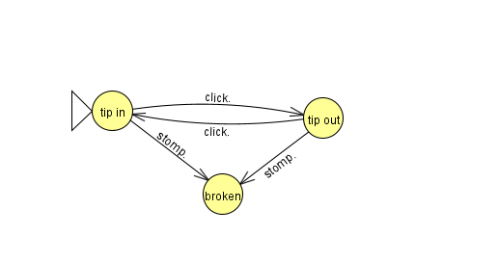

* The DFA is now an NFA because there is no stomp action that goes from tip in to tip out and vice versa.
* There was no issue with the input of click.click.click.stomp. but there was an issue with the input of click.click.click.stomp.click.. This is because there is no way to escape the broken state by using the click action.

**Part 2:**